FINAL YEAR GROUP PROJECT
Ephemeral Anonymous Messaging System(EAMS)
Group Members:
1. Athman Ibrahim BSCCS/2022/48631
2. Joseph Kihamba BSCCS/2022/33117
3. Mohamed Ali Bore BSCCS/2023/45387
4. Derek Wango BSCCS/2022/59177
5. David Muchai BSCCS/2023/39100

Supervisor: Md. Elena Mwai

The design and implementation of an ephemeral zero-trust communication protocol using a stateless relay architecture

Table of Contents
Phase 1 – Research & Documentation 5
1.1. Introduction 5
Main Objective 5
Research Question 5
1.2. Threat Model 5
1.3. Technology Stack 6
1. Client Security Core 6
2. Mobile Application 6
3. Relay Server 6
4. Cryptography 7
1.4. Team Responsibilities 7
1.5. Development Timeline 8
Phase 1 – Research & Documentation 8
Phase 2 – System Design 8
Phase 3 – Rust Fundamentals 8
Phase 4 – Go Relay Server 8
Phase 5 – React Native UI 8
Phase 6 – Integration 9
Phase 7 – Testing 9
Phase 8 – Documentation Updates 9
Phase 9 – Presentation Preparation 9
Phase 10 – Buffer 9
1.6. Project Deliverables 10
1.7. Risk Register 10
1.8. Success Criteria 10
Phase 2 – Engineering Design 11
2.1. System Context View 11
Purpose 11
Objective 11
Description 11
Key Design Decisions 11
2.2. Logical Architecture View 12
Purpose 12
Objective 12
Description 12
Key Design Decisions 13
Observations 13
2.3. Communication Flow View 14
Purpose 14
Objective 14
Description 14
Key Design Decisions 15
Observations 15
2.4. Trust-boundary View 16
Purpose 16
Objective 16
Description 16
Key Design Decisions 17
Observations 17
2.5. Key-exchange View 18
Purpose 18
Objective 18
Description 18
Key Design Decisions 19
Observations 19
2.6. Message Lifecycle View 20
Purpose 20
Objective 20
Description 20
Key Design Decisions 21
Observations 21
2.7. Deployment View 22
Purpose 22
Objective 22
Description 22
Key Design Decisions 23
Observations 23
2.8. Security Architecture View 24
Phase 3: System Design 25

Project Review

Phase 1 – Research & Documentation

Introduction
Modern communication systems permanently accumulate data about who we talk to, when we talk, and often require persistent identities.
GhostRelay investigates whether secure communication can occur while minimizing that retained information through an ephemeral, zero-trust relay architecture.

Main Objective
To design and implement a communication protocol that allows users to exchange end-to-end encrypted messages through an untrusted relay server without maintaining persistent identities or message histories.
The protocol should ensure:
- Client-side key generation
- Out-of-band public key exchange
- One-time message retrieval
- Automatic message destruction
- Zero-trust relay operation
- Minimal metadata retention

Research Question
Can communication occur securely even when the server is never trusted?

Threat Model
We will design the system to actively defend against six specific adversaries:
- Curious Users: Blocked via strict database access controls.
- Malicious Relays: Rendered harmless because payloads are fully encrypted before reaching them.
- Network Eavesdroppers: Defeated using TLS 1.3 encryption and fixed-size data padding.
- Replay Attackers: Blocked using strict cryptographic sequence counters.
- Impersonators: Prevented via out-of-band QR code fingerprint validation.
- Spam Attackers: Mitigated via client-side rate limits.

Technology Stack

1. Client Security Core
Language: Rust
Responsibilities:
- Key generation
- Encryption
- Decryption
- Secure random number generation
- Local key storage
- Message integrity verification

2. Mobile Application
Framework: React Native
Responsibilities:
- User Interface
- QR Code scanning
- Contact management
- Notifications
- Calling the Rust security library

3. Relay Server
Language: Go
Responsibilities:
- Receive encrypted payloads
- Temporary RAM-based message storage
- One-time retrieval
- Automatic message expiration
- Concurrent connection handling

4. Cryptography
Algorithms and libraries:
- Curve25519 (Key Exchange)
- Ed25519 (Digital Signatures)
- XChaCha20-Poly1305 (Authenticated Encryption)
- SHA-256 (Fingerprints)
- libsodium / RustCrypto libraries

Team Responsibilities

Team Member | Responsibility
Member 1  (System Architect) | System architecture, protocol design, integration, code review
Member 2  (Frontend Developer) | React Native client and navigation
Member 3  (Backend Engineer) | Go relay server and APIs
Member 4  ( Research) | Documentation, and report preparation
Member 5  (Quality Assurance) | Rust security testing and Code review

Development Timeline

Phase 1 – Research & Documentation
Deliverables:
- Software Requirements Specification (SRS)
- Threat Model
- Protocol Version 1

Phase 2 – System Design
Deliverables:
- API Design
- Database Design (RAM Storage)
- System Architecture

Phase 3 – Rust Fundamentals
Deliverable:
- Cryptographic Prototype

Phase 4 – Go Relay Server
Deliverable:
- Temporary Message Relay

Phase 5 – React Native UI
Deliverable:
- Basic Client Interface

Phase 6 – Integration
Integrate:
- Rust
- React Native
Goal:
- End-to-end encryption functioning correctly.

Phase 7 – Testing
Conduct:
- Functional testing
- Security testing

Phase 8 – Documentation Updates
Produce:
- User Manual
- Technical Report

Phase 9 – Presentation Preparation
Prepare:
- Presentation slides
- Demonstration

Phase 10 – Buffer
Activities:
- Bug fixing
- Performance improvements
- Final polishing

Project Deliverables
By project completion, the following should be available:
- Protocol Specification
- Software Requirements Specification (SRS)
- Threat Model
- System Architecture Design
- React Native Client
- Rust Security Library
- Go Relay Server
- Marketing Website
- User Manual
- Technical Documentation
- Presentation Slides

Risk Register
Table 1: Risks likely to be encountered and their respective mitigation plan
Risk | Mitigation
Rust learning curve | Build small prototypes first
React Native + Rust integration | Delay integration until the Rust crypto library is stable
Cryptographic mistakes | Use only audited cryptographic libraries
Scope creep | Lock the MVP before coding
Uneven group participation | Assign clear ownership early

Success Criteria
A successful MVP should allow:
- Two users to generate local identities.
- Public keys to be exchanged externally.
- Messages to be encrypted locally before transmission.
- Messages to be delivered through an untrusted relay server.
- The relay server to be unable to decrypt messages.
- Messages to self-destruct after retrieval.
- No persistent message history to exist.

Phase 2 – Engineering Design

System Context View

Purpose
The System Context Diagram provides a high-level overview of GhostRelay and its interaction with external actors and systems. It identifies the primary users, supporting infrastructure, and the trust relationships established during communication.

Objective
To demonstrate the overall operating environment of GhostRelay before examining its internal architecture.

Description
GhostRelay facilitates communication between two users through an intermediary relay server. The relay acts solely as a transport mechanism for encrypted payloads and is not trusted with message contents or cryptographic keys. Public keys are exchanged outside the communication channel, ensuring the relay never participates in key establishment.
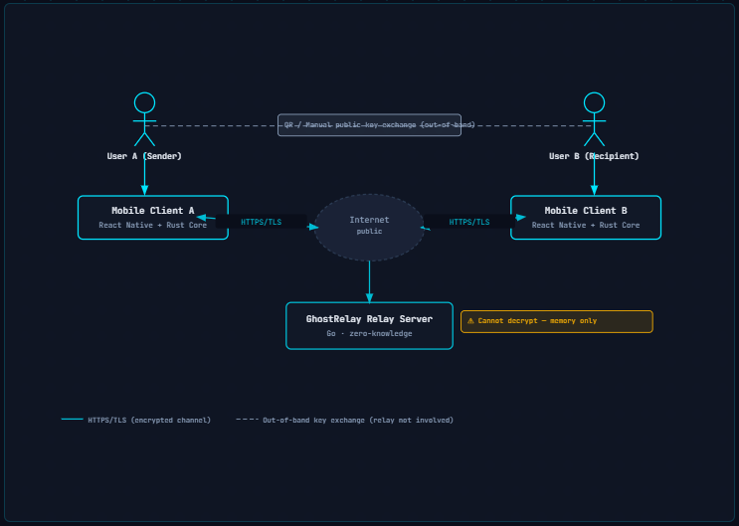
Figure 1: System Context Diagram

Key Design Decisions
- The relay is considered untrusted.
- Public key exchange occurs out-of-band.
- All message encryption occurs locally.
- Only encrypted payloads traverse the network.

Logical Architecture View

Purpose
The Logical Architecture View illustrates the major software components that constitute GhostRelay and defines their individual responsibilities. It provides a high-level understanding of how the application is partitioned into independent modules while maintaining a secure communication workflow.

Objective
To demonstrate the internal organization of GhostRelay and highlight the separation of responsibilities between the user interface, cryptographic engine, relay server, and supporting infrastructure.

Description
GhostRelay adopts a layered architecture that separates presentation, security, communication, and infrastructure concerns. The React Native mobile client provides the user interface, while all cryptographic operations are delegated to the Rust Security Core. Communication with the relay server is performed over encrypted HTTPS/TLS connections. The relay server, implemented in Go, is responsible only for temporarily forwarding encrypted payloads without accessing their contents.
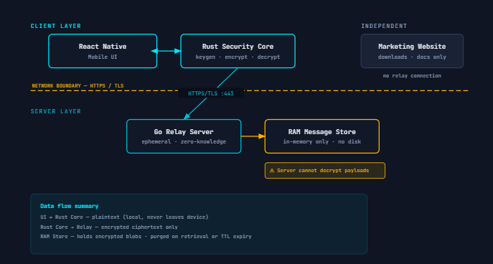
Figure 2: Architectural view
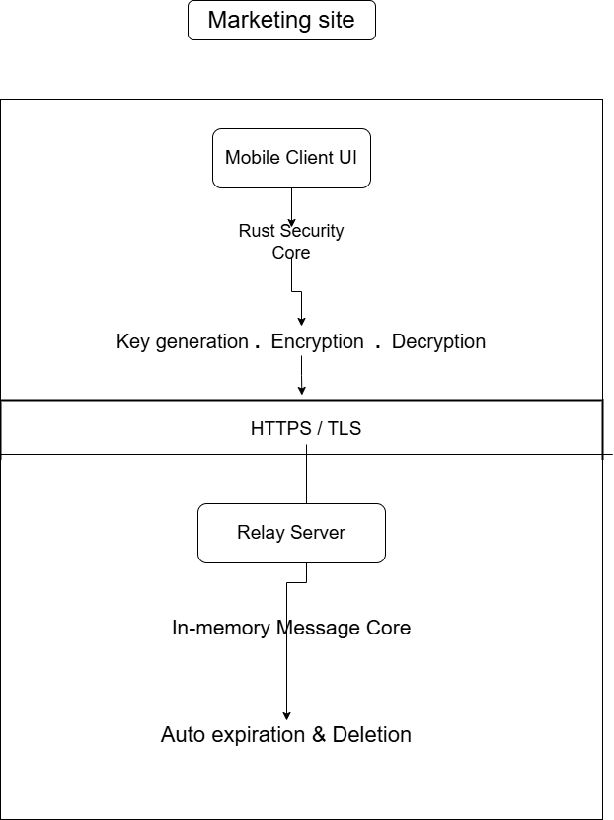

Figure 3: Architectural flow

Key Design Decisions
- Separation of presentation and security logic.
- Cryptographic operations isolated within the Rust Security Core.
- Relay server limited to encrypted message forwarding.
- Temporary in-memory storage used instead of persistent databases.
- Independent marketing website separated from the communication system.

Observations
This architecture minimizes the attack surface by ensuring that cryptographic material never enters the server environment while maintaining clear boundaries between software components.

Communication Flow View

Purpose
The Communication Flow View illustrates the complete sequence of events that occur during secure message transmission between two users.

Objective
To describe the lifecycle of encrypted communication from key generation through message destruction.

Description
Communication begins when both users generate independent cryptographic key pairs. Public keys are exchanged through an external trusted channel before encrypted communication begins. Once trust is established, messages are encrypted locally and transmitted through the relay server. The relay temporarily stores encrypted payloads in volatile memory before forwarding them to the intended recipient. Upon successful retrieval or expiration, the relay permanently removes the encrypted payload according to the protocol.
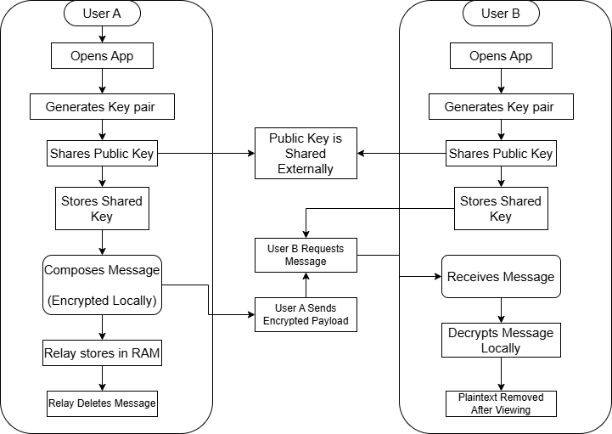

Figure 4: Communication Flow

Key Design Decisions
- Public key exchange occurs outside the communication protocol.
- Encryption occurs before network transmission.
- Messages remain encrypted throughout transit.
- Relay performs temporary forwarding only.
- Messages are automatically destroyed after retrieval or expiration.

Observations
The communication workflow ensures that confidentiality is preserved throughout transmission while minimizing message persistence within the relay infrastructure.

Trust-boundary View

Purpose
The Trust Boundary View identifies which components are considered trustworthy and which are assumed to be potentially hostile. It establishes the security assumptions that guide GhostRelay's protocol design.

Objective
To clearly define where sensitive operations occur and demonstrate how confidential information is protected from untrusted infrastructure.

Description
GhostRelay assumes that only the client device and its locally stored cryptographic material are trusted. The relay server, communication network, and any intermediate infrastructure are treated as untrusted environments. Consequently, all sensitive operations—including key generation, shared secret derivation, encryption, and decryption—are executed exclusively within the trusted client boundary.
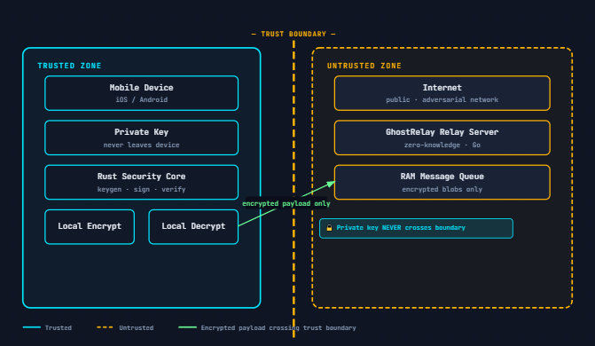
Figure 5: Trust Boundary View

Key Design Decisions
- Private keys never leave the client device.
- Shared secrets are derived locally.
- Plaintext messages never cross the trust boundary.
- Relay servers never possess sufficient information to decrypt messages.
- Communication occurs only through encrypted payloads.

Observations
By minimizing the trusted computing base, GhostRelay reduces the impact of infrastructure compromise and reinforces its zero-trust communication philosophy.

Key-exchange View

Purpose
The Key Exchange View illustrates how two users establish a secure communication channel without transmitting private cryptographic material.

Objective
To demonstrate the secure establishment of a shared secret while preventing relay-based key substitution attacks.

Description
Each user independently generates a public/private key pair during application initialization. Public keys are exchanged through an external communication method such as QR codes, manual verification, or trusted messaging channels. Once the public keys are verified, both clients independently derive an identical shared secret using an agreed key exchange algorithm. The shared secret is then used to encrypt and authenticate future communications.
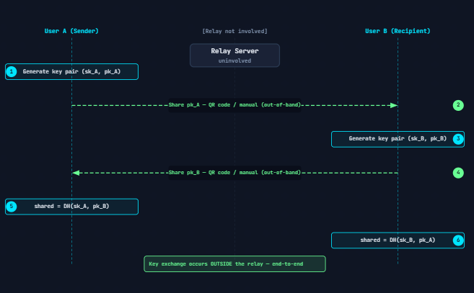

Figure 6: Representation of a Key exchange

Key Design Decisions
- Key generation occurs entirely on the client.
- Private keys are never transmitted.
- Public keys are exchanged out-of-band.
- Shared secrets are independently derived.
- Relay infrastructure never participates in key establishment.

Observations
Separating key exchange from message transmission significantly reduces the possibility of relay-assisted man-in-the-middle attacks.

Message Lifecycle View

Purpose
The Message Lifecycle View describes how a message is created, transmitted, consumed, and securely destroyed throughout its existence.

Objective
To define the complete lifecycle of a GhostRelay message while demonstrating adherence to the project's ephemeral communication philosophy.

Description
A message originates within the sender's trusted client environment, where it is encrypted using the established shared secret prior to transmission. The encrypted payload is temporarily retained by the relay until retrieved by the intended recipient or until its expiration period elapses. Following successful delivery or expiration, the relay permanently removes the encrypted payload. Upon decryption, the recipient views the plaintext message, which is subsequently removed from the client interface in accordance with the application's secure deletion policy.
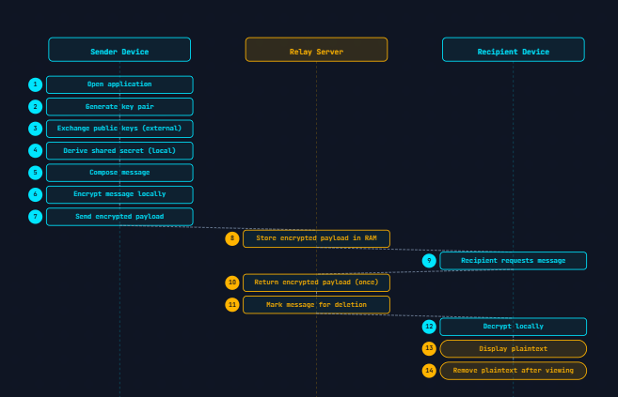

Figure 7: Message Lifecycle

Key Design Decisions
- Plaintext exists only within trusted client memory.
- Messages remain encrypted during storage and transmission.
- Relay stores encrypted payloads only temporarily.
- Automatic deletion occurs after retrieval or expiration.
- Client removes plaintext after viewing.

Observations
The controlled lifecycle minimizes the exposure of sensitive information and reinforces GhostRelay's objective of reducing long-term data persistence.

Deployment View

Purpose
The Deployment View illustrates the physical distribution of GhostRelay's software components across client devices and server infrastructure.

Objective
To identify where each component executes and describe the communication paths between deployed services.

Description
The GhostRelay client is deployed on Android devices and consists of a React Native user interface integrated with a Rust-based cryptographic engine. Communication occurs through secure HTTPS/TLS connections to the relay server hosted independently. The relay maintains only temporary encrypted payloads within volatile memory. A separate marketing website provides project information and application downloads without interacting with the secure communication infrastructure.

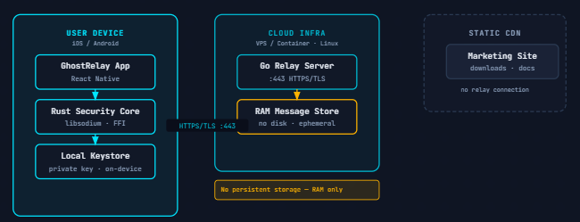

Figure 8: Deployment View

Key Design Decisions
- Client-side deployment isolates cryptographic material.
- Relay deployed independently of client applications.
- Marketing platform separated from secure communication services.
- Temporary RAM storage replaces persistent databases.
- Secure transport enforced through HTTPS/TLS.

Observations
This deployment strategy maintains a clear separation between user-facing services and secure communication infrastructure while simplifying scalability and maintenance.

Security Architecture View

Table 2: Security Architecture
Security Objective | Design Mechanism
Confidentiality | End-to-end encryption in the Rust Security Core
Integrity | Authenticated encryption and message authentication
Authentication | Out-of-band public key verification
Forward Secrecy | Ephemeral session key derivation (where supported in the protocol)
Metadata Minimization | Stateless relay and RAM-only message storage
Availability | Lightweight concurrent Go relay server

Phase 3: System Design

